The stem cells, bioengineering and cellular technologies in regeneratore medicine.
Tomsk polytechnical university
e-mail: biocell@ngs.ru

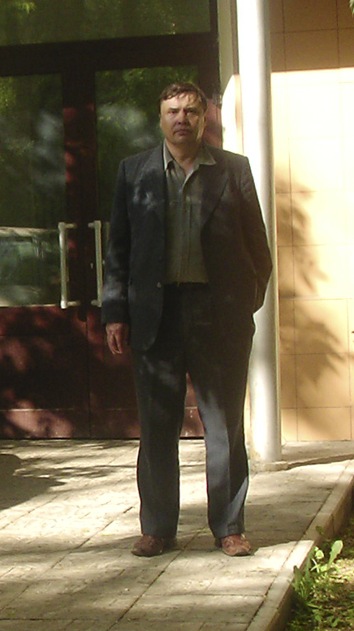
V. Shahov, professor, MD

The XX century and the beginning XXI of the century were marked by basic opening in the field of biology and medicine (the journal "Science" ,1999, 2007)). It this:
1. Decoding of a double spiral of DNA;
2. Definition genome of the human;
3. Opening embryonic stem cells of the human and animals;
4. Opening multipoitent iPS cells of he human and animal.
The stem cells have high plasticity, multipoitent, proliferation and differentiation potential. It gives to cellular technologies greater scientific, practical, commercial and innovative importance. Evolution регенераторной medicine means full reconstruction not only fragments of ograns and tissue (valves, joints, bones, vessels, nerves, a liver, a brain and another), but also all organism and its main systems (haematopoietc, neuro-endocrine, immune, reticulo-endothelia, reproductive) [Assmus et al., 2004; Shahov, Popov, 2004; Diederichsen et al., 2006; Yamanaka, 2007; Tomoda, Yamanaka.2007; Hochrdlinger et al., 2007; Passier et al., 2008;Ahahov et al., 2007, 2008; Sommer et al., 2009].
Who in perfection owns cellular technologies, bioengineering and creates artificial bodies and the tissues to that posesses the future of the world.
It is the most probable, that new systems will be combined with the intellectual materials containing microchips, нано robots.
Example of one of first such systems can become bioincubator on the basis of porous nikelide of the titan. Into this three-dimensional design entered stem cells and successfully cultivated during the long period of time in systems in vitroand in vivo (Figure.1).

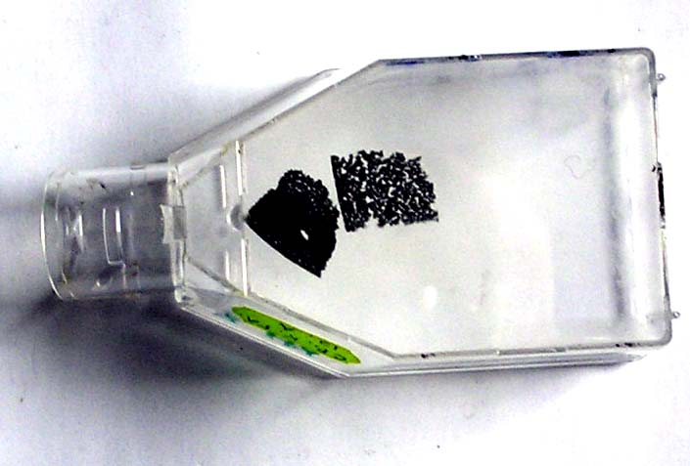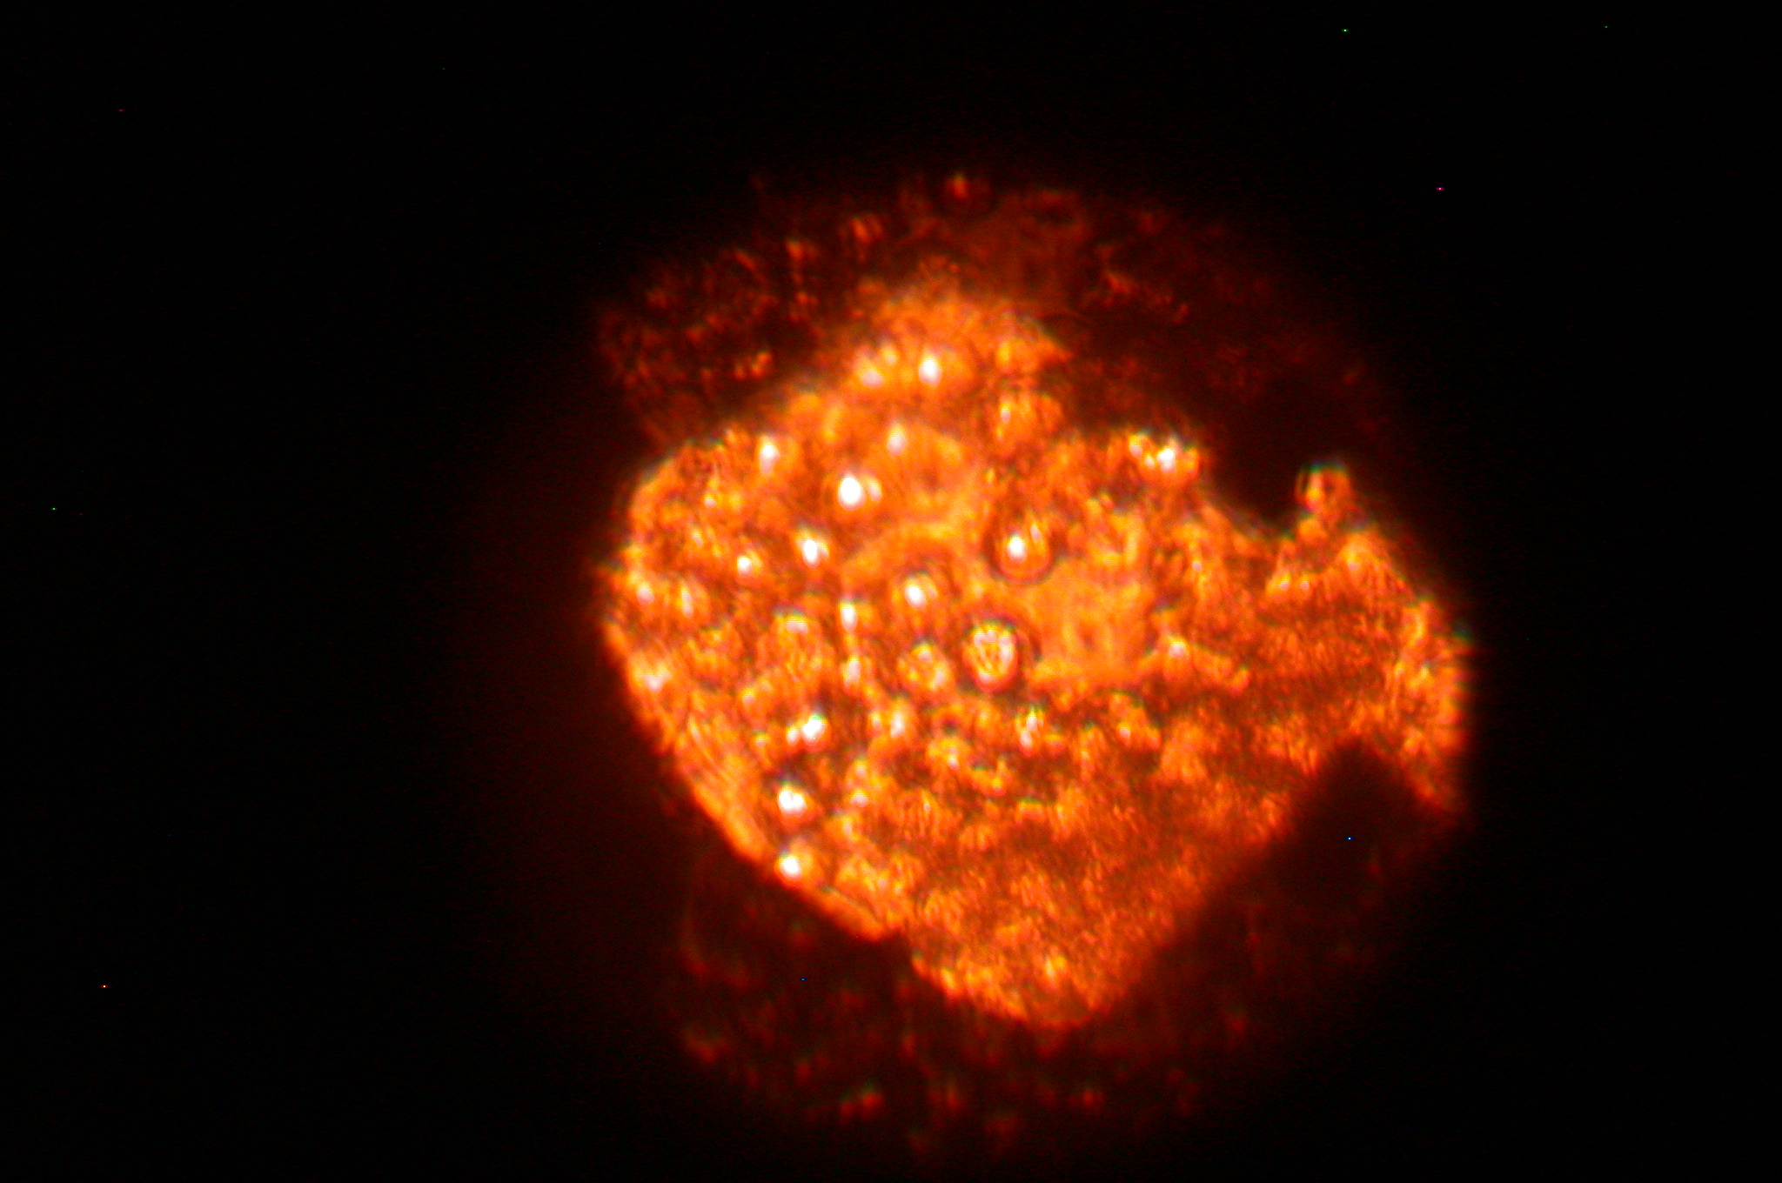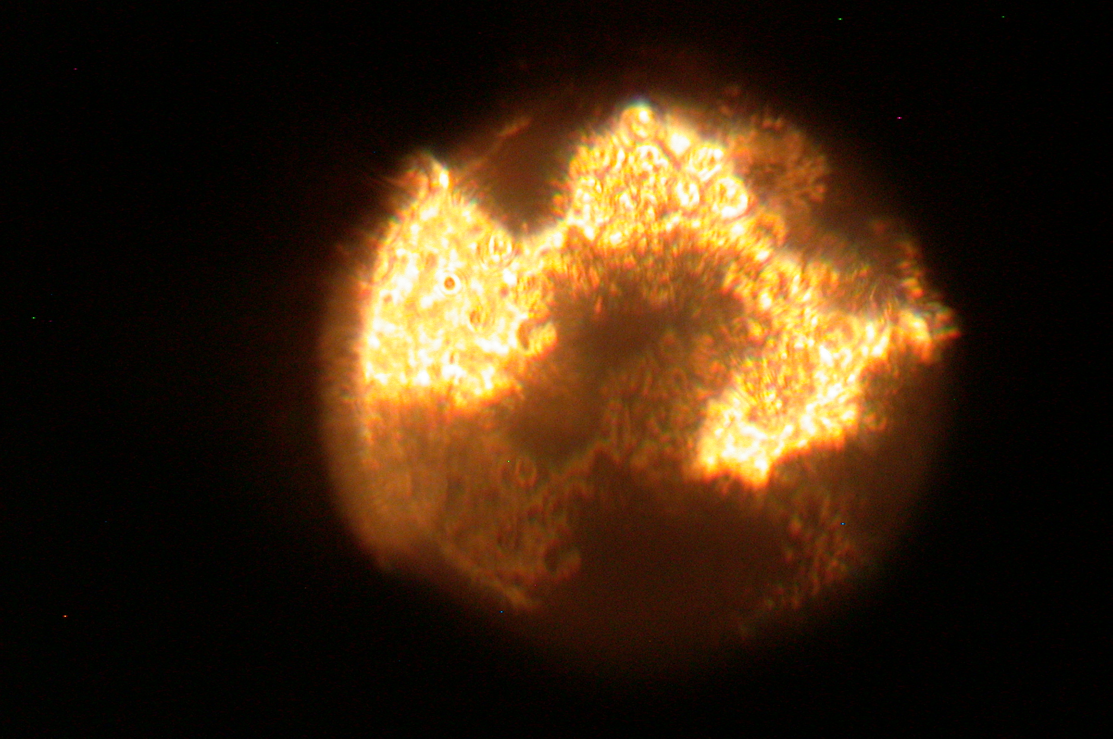
1. 2. 3.
Figure.1. Culture of cells of a bone brain of mice of line СВА on porous nikelide the titan in vitro. 1 - Macro preparation. 2 and 3 (micro preparations) separate times about mesenchymal stem cells of the bone marrow on the 10 day of the cultivatuon (200х) [Shahov, Popov, 2004].

The 21 century is key for the further development of medical materiology. In medicine began to be applied actively metal, ceramic, composite, calcium phoshate materials, bioglass and polymers. By development of new materials for needs of traumatology, orthopedy, stomatology, cardiology, etc. sections of medicine. The implants should pass all stages. These stages include: occurrence of idea. Then the idea is embodied in experimental model. It is exposed to biological, toxicological, toxicological, cancerogenic, biocompatible tests. In parallel проводяь the technological tests, necessary examinations, were including a choice of a material, definition of reliability of a product or a design, results of preclinical, clinical researches and estimations of cost of their manufacture.
Medical materials should be hi-tech, biocompatible, not toxic, rather simple in manufacturing, economic, to have a necessary raw-material base, steady against sterilization and to carry out the functions for all term of the operation put by it, safe and profitable. Finally, the doctor the cardiologist, the traumatologist, the orthopedist or the stomatologist should have all necessary information on that what material better to choose and as it to use at treatment of patients and what can arise thus of complication.
On the other hand, experts on medical materiology not only should have all necessary skills at creation of optimum materials, but also know related subjects, including bases of construction of bodies, tissueses, cells during morphogenesis and embryogenesis in norm and a pathology which should be used effectively in designing new bioengineering devices, implants and bioengineering systems.
Any implants or the biomaterial, at introduction in an organism leads to formation of stereotypic responses. They are shown in the form of damage (destruction, deformation, neucrosis) structures and functions of tissues and organs (biomechanical, biochemical, electrophysiological, etc.) and extracellulare matrix (collagen, elastin, proteine, glicoseaminoglicans, change of structure of a crystal structure etc.) . Then the damaged structures during inflammatory reaction leave by фагоцитоза macrophages, dissolution or biodegradation. In turn products of disintegration of the tissuese and inflammatory reactions around of the implant stimulate start of processes of regeneration and a reparation of the damaged structures which are in full or in part restored with participation stem cells and their more differentiated descendants. Vessels and nervous fibres are in parallel reconstructed. There is an integration имплантата to surrounded fabrics and bodies in the form of a complex bioengineering design. If character of damage has irreversible character the formed defects are filled with a fibrous fabric in the form of stromal capsules are replaced with other cellular elements (fatty, tumoral) or filled with an interfabric liquid. Besides имплантат it can simply be superseded from an organism or collapse as a result of deformation, dissolution or dissolution and degradation. Thus products of disintegration implant and cells can cause development the immunology conflict, formation of allergic reactions silt of a chronic inflammation (Shahov et al., 2007, 2008, 2009).
From general-theoretical positions each stage coming after implantation, depending on characteristics of a material and a condition of an organism, can proceed on three basic stereotypes: hypoenergyc (bioinertness), normoenergyc (osteoconduction - OC) and hyperenerrgyc (osteoinduction -OI).
Bioinert materials (BIM) need to be applied at treatment infection of the traumas and crises. At a bony rarefication, osteomalation, the difficult cause and old patients it is necessary to use bioactive implants. If implant was in an organism during all life use osteointegrative materials.
Biological activity calcium of phosphatic materials (CP) (hydroxiapatite HA, trycalcium phosphate - TCP, fluoride apatite -FA) can possess straight lines and (or) mediated (OC, OI) biological action. Their mechanisms are realized through a circuit of consecutive events. They include: adhesion circulating in blood and an intercellular liquid of ions, molecule of adhesion , integrins, selectins, growth and other factors. They create humoral a microenvironment and stimulate migrating on the implant of MSC. Then these stem cells start to proliferations and differentiations. As the academic of Russian Academy of Medical Science V.N.Yarygin has told: « There has come time when we pass from a cellular material to a cellular product and to cellular technologies ». There are active works on studying properties the nanostructural titan, calcium of phosphates, bioglass and active bioceramics [Carlov, Shahov, 2001; Vereshagin et al., 2008,2009; Shahov et al., 2008; Yarygin et al., 2008]
At creation of new biomaterials in medical materiology it is necessary to solve many questions and problems of practical character. In a particular it is a question of the technical problems connected:
1. With a choice of a material for implants.
2. Studying of its mechanical, physico-electro-chemical properties.
3. Designing of a product, carrying out of necessary engineering and design works.
4 Creation of a technological line of manufacture of a finished article; its sterilizations and packing.
In parallel carrying out of the biological researches connected is required:
1. Studying of biocompatibility implants.
2. Carrying out toxicological, local irritating, cancerogenic, allergenic, immune and mutagen, embryogenic properties of materials.
3. Development of optimum ways and ways about implantation of a material.
4. To study possible positive and negative reactions to introductions biomaterials during the early and remote period.
5. Carrying out of preclinical and clinical tests of a material according to requirements of the Ministry of social protection and public health services of the Russian Federation.
Besides it is necessary to solve legal and commercial questions. They concern иатентных works, certification of finished articles of their line on their manufacture, storage, transportations. Besides the finished article or technology should be included in the register of medical products of the Russian Federation, and their clinical use is authorized the Ministry of social protection and public health services of the Russian Federation.
That a product successfully to advance in a wide practice carrying out all marketing researches, definition of a commodity market, the price of manufacture and a finished article, down to the conclusion of concrete contracts is required.
Application in clinic implants with put on them stem cells, for the present poorly effectively. Introduction of any implant in a bone tissuse causes their damage,neucrosis, an inflammation [Majansky, 1981; Ilizarov 1989; Karlov, Shahov, 2001; Shumakov 1990). The zone of an inflammation has low maintenance of oxygen. Macrophages and leukocytes allocate numerous lysosomal enzymes. Acidity raises and the maintenance of ions (calcium, kalium, magnesium and chlorine) increases. These factors destroy of the stem cells due to lysis, an osmotic shock, hypo oxidation, neucrosis and apoptosis. It has appeared, that stem cells work only when processes of tissue regeneration and reparation around implant was begin. The phase of an inflammation comes to an end and the stage of growth and replacement of the damaged structures (a phase of regeneration) begins. Thus form a new tissue. During this period time the tissuse and organ into which it is entered implant, require in stem and differentiation elements. When stem cells are applied in a stage of fibrousis by them do not work [Shahov,Popov, 2004] (figure .2).

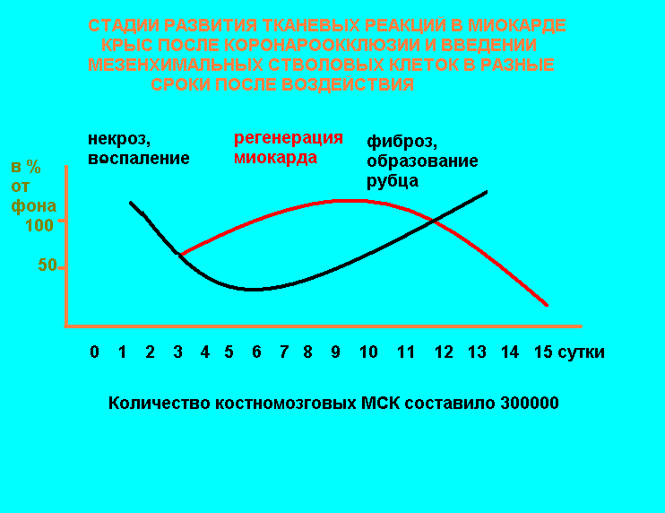
Figure 2. Influence of introduction of the MSC in a myocardium at modelling a sharp heart attack of a myocardium by means of coronaroocclusion in experiment on laboratory animals in various stages of pathological process (1 - a stage neucrosis and an inflammation, 2 - a stage of regeneration and reparation of the damaged structures, 3 - a stage of fibrosis).
Myocardium, other intimately vascular diseases, it is possible to subdivide cellular therapy of a heart attack into a number of the cores of group, depending on that what cells use at its carrying out:
1. Specific (the cells-predecessors forming a new tissuse, in particular intimate - muscular and vascular);
2. Nonspecific (the auxiliary cells, producing cytokines, growth factors, microcells, etc.).
3. Combined.
In the first case use reprogrammed in a direction of the cardiomyogenesis MSC of bone marrow, fatty tissue, placenta, etc. which at hit in a myocardium are capable to proliferation and to division with formation morpho-functional units which have been built in the damaged intimate tissuse. In the second - induce in cells-targets production, linkage of the various bioactive molecules providing processes reparation and regeneration. In the third - both combine this is method. Besides the combined technologies mean application of bioartificial limbs of vessels, valves of heart, biological cardiostimulator in various combinations of cells and biomaterials.
As marks Teruo Okano (2001) and other researchers intellectual biomaterials on the basis of polymers, can become the basic for development of new biomedical systems, and also carriers of medicines which have a feedback mechanism and liberate it from itself a preparation, for example, insulin, depending on a level of sugar or insulin in blood (Thomson, 2001; Okano, 2001; Maeda et al., 2003; Rohrbangh 2004). Intellectual materials cannot be identified with information systems since an alive organism and even any cell represents complex, multilevel system in which all its structures harmoniously work. They should possess not only ability to perception of the information, its transfer to an analytical complex which spends the analysis of data, but also development of adequate tactics and strategy for the further actions and their realizations in the form of the return afferentation the answer. The elementary example of such system can be cardiostimulator used for treatment of patients with infringements of a rhythm of heart. With обще theoretical positions of medical materiology the further development of such devices, can become biological cardiostimulator. Such system does not require the power supply, is directly in a myocardium and can work in current of all life without replacement.
Example of intellectual materials in traumatology, orthopedy and stomatology, can be metal implants inside of which under a layer bioactive calcium phosphate film nutrients, stem cells, etc. have system of microcapillaries and microelectrodes (gauges) in which of an environment move necessary growth factors and drug [Shahov et al., 2008, 2009 ]..
If to use touch microelectrodes it is possible to carry out the control over a condition of cells around implantт. It is possible to estimate as processes of its interaction with bone or other fabric of an organism (некроз, an inflammation, regeneration, functioning, etc.) proceed. The provisional scheme of such intellectual material is presented on figere.3. In this case, receipt of substances, medical products, ростовых factors, стволовых or the differentiated cells, is carried out through catheter.

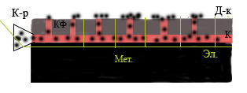
Figure 3. The schematic image multipurpose intellectual имплантата. Мет - a metal substrate. K-p - cathetor, through it necessary ions, molecules, medical products, hormones, growth factors, cells, etc., on a surface of implant through a network of microcapillaries. By means of parallel . Эл.-electrodes and Д-к - detector, currents of an inflammation, processes of regeneration, integration, etc. the information on a condition of tissuse and cells gathers for surfaces (around) of the implant for the further analysis [Shahov et al., 2009]..

The generalizing literary and own data it is possible to formulate main principles of cellular therapy and medical materiology which include:
- Principle of biocompatibility. (Immunology, haematology, electro-physiological, mechanical, etc. types of compatibility, for allogenic, autogenic, ksenogenic and fetal stem cells, cellular lines, hybrid, biosystem, implant, nanomaterial and biomaterial).

- Principle of similarity (mimetic).
In an organism there should be descendants stem cells of three germinal leaves (ectodemal. Endodermal and mesynchymal). For each disease it is necessary to use corresponding type stem cells from which they are formed. Hopes also connect with the directed manipulations above DNA of cells-targets which will be built in the genetic material responsible for cardial, vascular, neural a differentiation. HA and TCP are natural methabolite of the bone tissuse and consequently concern to a class biomemmetic.

3. Principle of adaptation (cells, biomaterials for to transplantation).
About 30-80 % transplantation cells perishes at introduction in an organism (ischemia, thermal influence, inclusion of mechanisms апоптоза and neucrosis) or leaves a zone of introduction due to migration within 1-4 day. To lower these losses, it is necessary to lead before transplantation preparation (adaptation) of cells for introduction to the damaged fabric. Unfortunately, the information on the given question has not enough. About decrease concentration of oxygen up to 2-5 % (hypo oxidation), rise in temperature up to 40-41^{о}С (hypertermia ) first of all is a question at cultivation of the cells-targets with the purpose of increase of their stability to the subsequent transplantation. Biomaterials it is desirable before introduction in an organism in addition to adapt by drawing on their surface growth factors, molecules of adhesion or even stem cells for acceleration of processes osteoinduction, osteoconduction and osteointegration.
- Principle of duly introduction of cells and biomaterials.
It is expedient for using at sharp diseases, for example, a heart attack of a myocardium. In our experiments begun in 2002-2004 it has been shown, that at modelling a heart attack of a myocardium transplantation of the MSC is effective only during between the termination of reactions neucrosis (the first and second wave), inflammations and the beginning of process sclerosis a myocardium. Introduction of cells during an inflammation 1-5 day or during the moment of formation рубца (after 24 day) does not lead to braking of development of intimate insufficiency. MSC do not form new cardiomyocytes, vesel cells and perish as a result of apoptosis or neucrosis. During initiation of fibrosis of the MSC follow a way of formation stromal elements.
5. Principle of "shaking" homestasis systems and preparation (activation) of a microenvironment (a myocardium, a bone fabric) to perception трансплантируемых cells orimplant.
Shaking » functional activity of a bone fabric widely uses in devices of external fixing at treatment crisis and refers to as a principle dynamization, i.e. creations of micromovements that accelerates processes of healing of crisis.

- Principle of address delivery.
Intravenous transplantation of the MSCat illness of heart is poorly effective. It is necessary address deliveries MSC in a myocardium around of a zone neucrosis. It is expedient to use navigating systems which build a three-dimensional picture of an intimate fabric - 3D, defining a zone of damage, and allows to deliver of the MSC in a myocardium with high accuracy.
Для материалов используемых в травматологии, ортопедии и стоматологии данный принцип использовался сразу с момента начала его применения при лечении переломов, травм позвоночника, когда появились первые металлические конструкции для проведения остеосинтеза или протезирования зубов.

- Principle иммобилизации a cellular material.
On the basis of data on use меченных isotopes MSC,immunologycal assay and histologic researches it is known, that they not only perish, but in 1-2 day after their introduction up to 60-70 % and more transplanted of the cells leave body where them drove due to hoyming and migrations in other fabrics and bodies. For implant MSC and embeddings of their differentiated descendants in reparation of the tissue is required not less than 6-7 day. The immobilization of thr stem cells it is possible to carry out due to their loading nanoferretics use of a strong magnetic field, change of a condition of a microenvironment, molecules of cells braking migration, applications of multicellular designs or the special carrier (matrix, scaffold and ect).

  - Principle of consecutive transplantations.
That cellular therapy has passed successfully it it is possible to spend to some stages. On an example of a heart attack of a myocardium it is possible to use such scheme of treatment. Originally into a myocardium enter mononuclear of the bone marrow (3-7 day). These cells promote growth of vessels and improve morpho-functional properties of an intimate tissuse. After formation of a vascular part start the second stage - reconstruction of a muscular fabric by transplantation reprogrammed in a direction кардиомиогенеза of the MSC (12-14 day, the period of the microenvironment of a myocardium made active to regeneration).
В стоматологии, например, используют сначала введение титанового имплантата с КФ покрытием в кость, а затем, спустя несколько дней надевают на него керамическую коронку, что улучшает приживление и функционирования всей конструкции.
- Principle of the directed training and rehabilitation of the reconstructed or again created морфо-functional structures.
At reconstruction of thet tissue and organ by means of stem cells or biomaterials there are new communication and morph-functional communications which are necessary for fixing. At a reparation of a nervous fabric after an insult again new neural tissuse fabric and complexes do not bear in itself the information. It is necessary to develop programs of training, rehabilitation or formation of new morpo-functional and information systems, and also widely to apply physiotherapeutic procedures, medical gymnastics that the patient has returned to normal ability to live. Analogy actions need to be used at restoration of impellent activity of finitenesses after crises, prosthetics of a backbone and joints.

The temp with which new materials and cellular technologies was in a clinical practice it is serious many researchers and experts. Often they are not proved патогенетически and developments possible early and, especially, the remote negative consequences of cellular manipulations (Checks, Priests, 2004 are spent without taking into account fundamental principles of regeneration, a reparation of alive systems, medical materiology, bioengineering and нанотехнологии, and also; Checks, etc., 2008; Shevchenko, 2006; Yarygin, 2008; Бурунова, etc., 2008). Стволовые cells began to consider as an original commercial biological product.
Despite of all achievements in chemistry, genetics, biotechnologies and cellular-molecular biology at pharmacologists terms of introduction of new medical products in a clinical practice from the moment of occurrence of idea before its practical introduction on the average make 10-15 and more years. It is caused by that except for experimental works, toxicological tests, it is necessary to carry out deep and all-round preclinical researches in public. A number of the companies and firm wish to receive as soon as possible commercial benefit from the investments enclosed in the project. However, as shows domestic and world experience, the share of introduction, apparently, perspective projects, in a real practice, makes no more than 3-5 %.
Once again it would be desirable to emphasize, that for the all-round analysis of use of biomaterials, implant, stem cells in medicine, it is required, processing of the information from thousand patients which supervision should be spent for many years on uniform technology, the requirements, developed for concrete diseases. For an intensification of this process it is necessary to unite all efforts in our country. And, it is impossible to be limited only to Moscow and Peterburg, but also to include in it other cities located in Centra regions, Ural, Siberian and other regions of Russia. Participants of the given project should not only exchange the achievements by technologies, but also operatively receive all necessary information, consultation from other establishments and to compare the results to similar parameters on the given method of treatment, to spend seminars, symposiums, conferences and congresses. For successful introduction of new materials and technologies it is required:
1. Developments of a necessary infrastructure.
2. Preparation of necessary number of the qualified experts on медцинскому to materiology, bioengineering and nanotechnology a wide structure on the basis of technical and medical and biologic universities of the country.
3. Creation innovative and внедренческих the centers and structures.
4. Creation of modern information base.
5. Financial and legal support of new projects and technologies.

