Development nanobiology and cellular technologies in Siberia (Tomsk).

- National research
University resource effective
Technologies.
- Faculty of technology of silicates
and nanomaterials of the
Tomsk Polytechnic university.
- The department of the
- structural macrokinetics
of the Tomsk science center of the
Siberian Branch of the
Russian Academy of science..

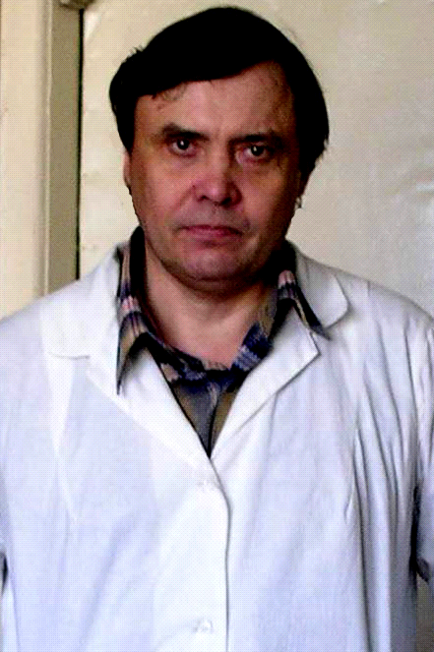
Vladimir Shahov, DM

Problem:.
The use of the multipotent mesenchymal stem cells (MSC) in medicine was non effective in cardiology in out times .
1. The exogenous and endogenous multipotent stem cells do not include in processes of regeneration and the reparation of the damaged tissues and organs.
2. The microenvironment of tissue does not possible include in heart of the endogenous or exogenous mesenchymal stem cells..
3. The MSC quickly leave at the place of introduction (migration, homing within 24-48 hours).
4. The MSC was multipotent and plasticizing elements. The MSC can be differentiated in other types cells (non myocardial) cells (stoma , fat, bone).

Ways of the decision of the this problems:
1. Address, introduction of the stem cells in damaged of tissue or organ.
2. Immobilization of the MSC with application by the help of the nanobiology.
3. The peryprogramming of the stem cells in the necessary direction of differentiation (myocardial, vessel).
4. Activation of the microenvironment of myocardium. It strengthens process of linkage of the stem cells with the tissue.

The experimental of model are occlusion of a descending coronary artery (OCA) of left ventricle of the heart.
- The OCA was imitation of the acute infarct of the myocardium.
- Is leads to formation of sharp and chronic intimate insufficiency.
- The coronary occlusion may be development of eth hypertrophy of the heart.
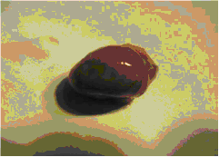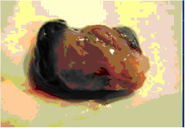
Norm of the heart 45 day after OCA (The hypertrophy of the
heart)

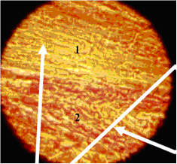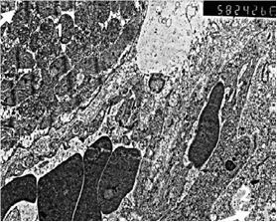
The histology (haematoxiline stein , 100x) The electronic microscopy (5829x)
1 - the intact myocardium , 2-zone of the necroses .

Stages of treatment of the heart disease after of coronary occlusion .

1. The extraction of the stem cells from the bone marrow.
2. The fast creation of the cellular masses by means of the bioreactor.
3. The reprogramming of the stem cells in the muscular type.
4. The loading of the stem cells with nano ferromagnetic by means of the bioreactor.
5. Clearing from ferromagnetic nanoparticles of the stem cells.
6. The activation of the microenvironment of the myocardium by means of dot radio frequency destruction (RFD).
7. Fixing of the stem cells with Fe₃O₄ by an external magnetic field.

The mesenchymal colonies in vitro (100х). A fragment’s of the mesenchymal
colonies ( 400х) (Painting, azure-II eosin).

Nanobiology.

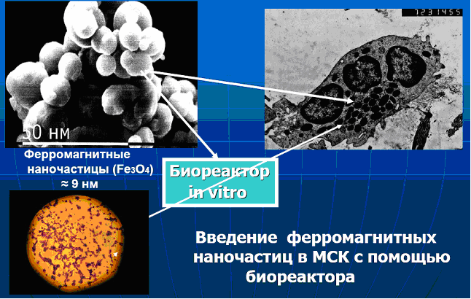

55,5 % of cells included in cytoplasm ferromagneticnanoparticles.
7,3 % of cells are attached of the nanoparticles magnetites on the an external membrane of the cells.
37,2 % of cells did not cooperate with nanoparticles.

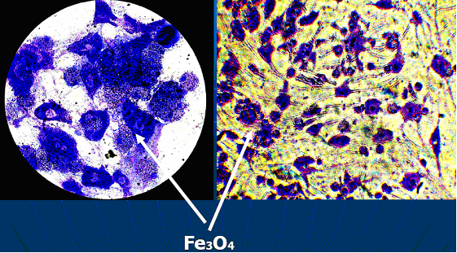

Behaviour of the mesenchymal stem cells in a magnetic field.

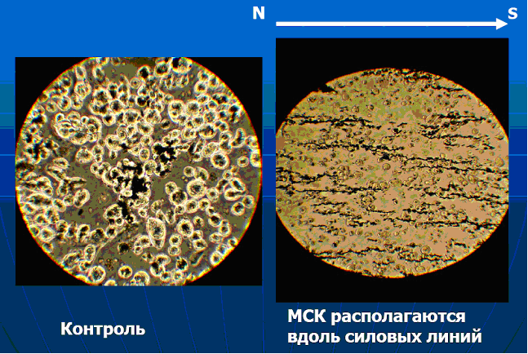
Control The MSC in magnetic field

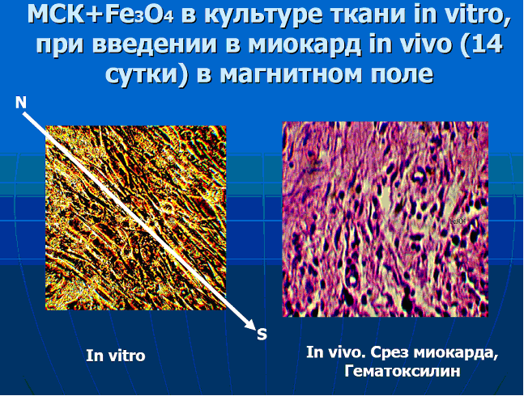
The multipotent stem cellls with nanoparticles react to action of an external magnetic field. The stem cells in suspension are built along power lines of a magnetic field. The growth of the cells in culture tissue in vitro was along power lines of a magnetic field.
In vivo the stem cells with Fe₃O₄ can be fixed in the magnetic fields. The 90% of the MSC after 30-45 day of the culture was without nanoparticles of Fe₃O₄.

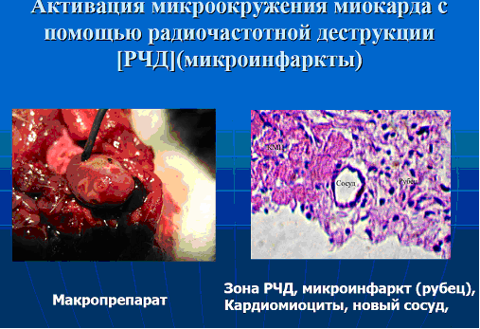

The microenvironment of a myocardium can be activated by means of dot radio-frequency destruction. It becomes susceptible to entered of the MSC.
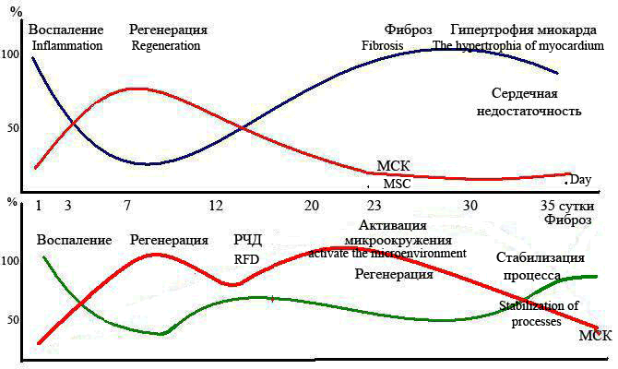

Introduction MSC is effective only during regeneration of a myocardium (3-14 day) after OCA (the "light" period for cellular therapy). However this efficiency does not exceed 45-47 % from the control. And, such parameters are reached when the MSC will in addition reprogram in the direction of the cardiomyogenesis, for example, by means of the 5-azacitidine. Without procedure reprogramming of the MSC their therapeutic effect does not exceed 3-5 %.
In a stage necroses and inflammations the MSC perish due to destruction, apoptosis or migrate from heart in other organs. Therefore they cannot accept active participation in regeneration of the myocardium.
Introduction of the MSC in a stage fibrosis they not only do not interfere with development sromal cells, but even strengthen its growth because they multipotent and are capable to be differentiated instead of the muscular cells in stromal elements.
If, is artificial to activate the microenvironment of a myocardium by means of dot radio-frequency destruction an intimate fabric it is possible to restore after process of formation stroma comes to the end. Thus pathological process is stabilized also chronic intimate insufficiency does not develop.

Conclusions:

1. Application нано biology and cellular technologies allows developing algorithm of treatment of sharp and chronic intimate insufficiency.
2. The original technology of inclusion ферро magnetic нано particles in cells is developed.
3. The technology and иммобилизации such cells by means of an external magnetic field is developed. Cells with нано particles keep the морфо functional properties.

The used literature:
1. Shahov V.P., Popov S.V. The stem cells and cardiomyogenesis in normal and pathology .Tomsk, STT.2004.170 p.
2. Shahov V.P., Popov S.V., Afanasiev S.A. The. plastic potential of the mesenchymal stem cells of the bone marrow for treatment of the diseases with damage heart tissues// J.Cardiology.-2005.N 2.P.45-46.
3. Shahov V.P., Kokaev O.V., Popov S.V. et al. The behavior of the mesenchymal stem cells containing of nanoferromagnetic particles in culture of a tissues in vitro Annual Russia and international scientific conference « Stem cells and prospect of their use in public health services Moscow., (on May, 24-25th) . 2006. P.74-78.
4. Shahov V.P., Kurilov I.N., Popov S.V.,Kostrikin A.A. The lecture on bioengineering and medical materiology Tomsk, STT.-2006. 240 p.
5. Shahov V.P., Latjushin J.V., Popov S.V., Sipok A.P. The principle of use of fundamental bases of the cellular and molecular bioengineering for increase of the physiological opportunities of the living systems Moscow , MGFU, 2008.252 p.
6. Shahov V.P., Bajkov A.N., Sipok A.P. The influence of the meso-mechanics on the morphogenesis of the mesenchymal stem cells The Annual Russia and international conference of the Stem cells and prospect of their use in medicine .-М.- RAMS, 2008. P..61-65..
7. The federal law of the Russian Federation from July, 27th, 2006 152-ФЗ « About personal data ».
8. The federal law of the Russian Federation from July, 27th, 2006 149-ФЗ « About the information, information technologies and about protection of the information ».

The address for the correspondence: e-mail: biocell@ngs.ru

